***PAAREES PERFUMES***

***THIERRY MUGLER***

***FOR MEN***

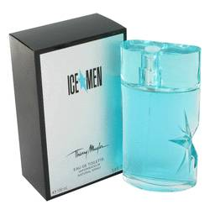

# 

***ICE MEN***

## *Description:*

Ice Men by Thierry Mugler Cologne. Ramp up your spontaneous adventures and business deals when you wear Ice Men fragrance from Thierry Mugler. Introduced in 2007, this rich masculine scent features invigorating notes of nutmeg and patchouli, with underlying musk and woodsy notes providing a smooth, long-lasting base. Ice Men is an ideal choice to elevate your confidence levels through the roof and envelop you in a sense-stimulating scent that impresses. Splash on a few drops of the fragrance before a work or family negotiation to win them over with your well-considered assertions.